# *Project Deliverable 1 Documentation*

## 

**Project Deliverable 1 Documentation** **1**

AWS Lambda 2

Lambda Function 2

Lambda function pulls data from the API data csv file 2

Python function to pull covid data from the API 3

S3 Bucket: 4

Python Code that converts JSON data to CSV 4

Output CSV File: 5

S3 Bucket: 5

## 

## 

## AWS Lambda

### Lambda Function

* Created a python script that contains the Lambda Function

### 

### Lambda function pulls data from the API data csv file

* Compressed the project directory with the python script and dependencies
* Uploaded the compressed file to S3 Bucket and linked it to the Lambda Function
* Currently working on the event trigger with Cloud watch

### 

### 

### 

### Python function to pull covid data from the API

* Python functions that are responsible for pulling the json data from the API

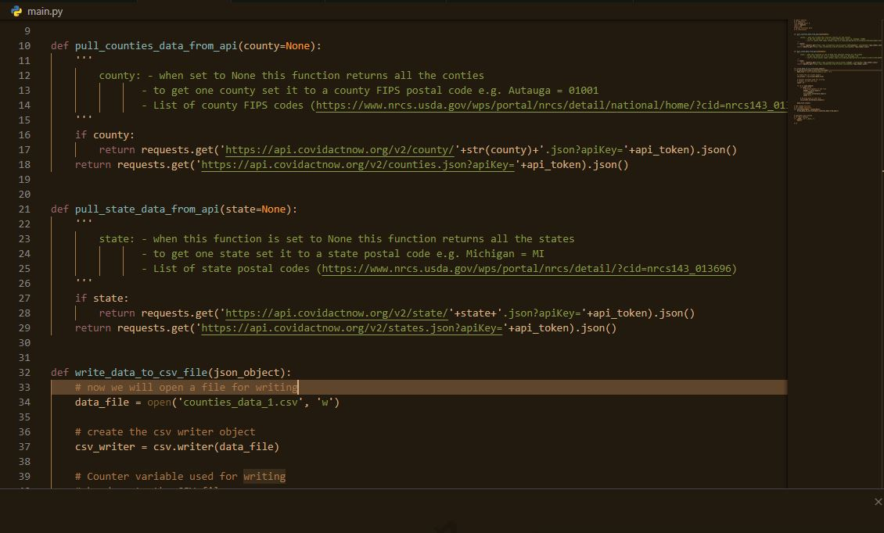

## 

## S3 Bucket:

### Python Code that converts JSON data to CSV

* Python code responsible to creating the CSV files

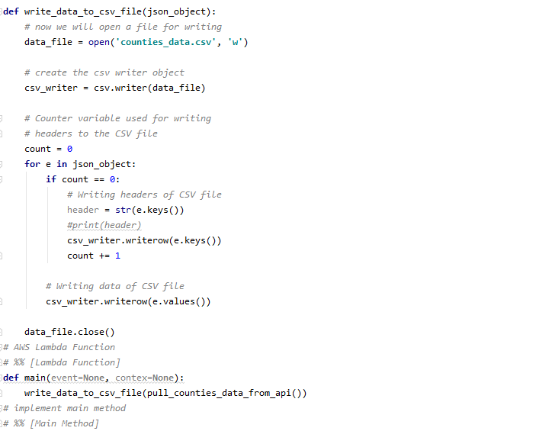

### 

### Output CSV File:

* CSV file with COVID-19 information about all the states

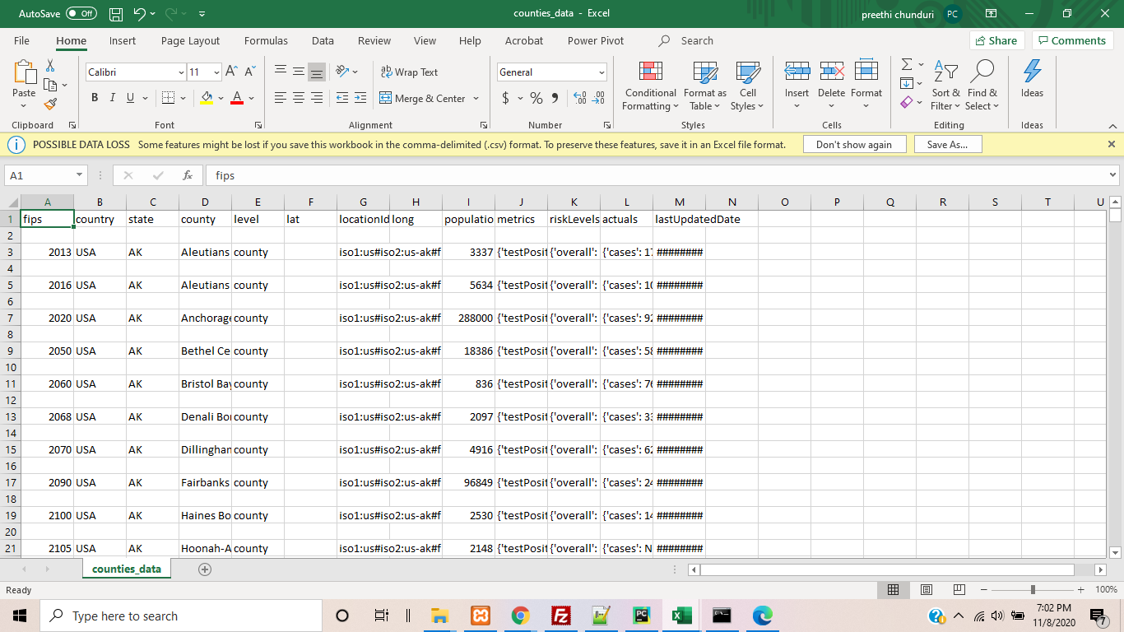

### S3 Bucket:

* Worked on creating a S3 bucket on personal AWS account
* Uploaded the python script

